**ECE3003 - MICROCONTROLLERS & ITS APPLICATIONS**



PROJECT REPORT

**THE PONG GAME**

SUBMITTED BY:

T. TEJAS - 18BEC0396 (L33+34)

K. AKSHAR - 18BEC0863 (L33+34)

**TABLE OF CONTENTS**

|  |  |  |
| --- | --- | --- |
| S. No. | TOPIC | PAGE |
| 1. | Abstract | 3 |
| 2. | Introduction | 3 |
| 3. | Overview of hardware | 4 |
| 4. | Project Specifications | 4 |
| 5. | Flow Chart of the Code | 5 |
| 6. | Code | 6 |
| 7. | Step-by-Step Report | 17 |
| 8. | Running the Game (DOSBOX Commands) | 22 |
| 9. | Results | 24 |
| 10. | Conclusion | 24 |
| 11. | References | 25 |

**ABSTRACT**

The aim of our project is to use 8086 assembly language, its interrupt services and an x86 DOSBOX emulator to create a legacy Pong game. It is a two-dimensional sports game that simulates table tennis. The player controls an in-game paddle by moving it vertically across the left or right side of the screen. It can also be played by two players who can control a paddle each using the keyboard. Players use the paddles to hit a ball back and forth. The goal is for each player to return the ball to the opponent successfully for as long as possible. The one who misses the ball first, loses.

We use three 8086 interrupt services out of the 256 available: INT 10H (for creating a new screen which provides video services, INT 16H (for allowing keyboard inputs to control the paddles on the screen), INT 21H (for using system time information to update the screen frame at regular intervals).

This project is completely based on software except for the keyboard inputs which the players will use to control the paddles.

**INTRODUCTION**

Video Games have become an essential part of any 21st Century kid, whether they be on mobile, PC or a console. Video Games have seen huge growth in the last 3 decades and are now truly unbelievable in terms of the overall experience they provide. But, the game industry had humble beginnings with the creation of games like Pong and Mario, written purely in assembly language. So, for our project, we have decided to create our own version of Pong written purely in Assembly Language as a tribute to the game developers of the days of yore.

This report contains details of the steps we went through to make this game and also highlights the issues we faced at each step. This game can be run on any system with the DOSBOX emulator and requires practically zero computing power due to its lightweight and super-fast execution times due to it being written in assembly language.

**OVERVIEW OF THE HARDWARE COMPONENTS**

We have used no hardware components except the keyboard which sends players’ inputs to the game. We have used an 8086 emulator which is a software that enables one computer system (called the host) to behave like another computer system (called the guest).

The host is the operating system in our laptops i.e. Windows 10, whereas the guest is the operating system being run on the host system i.e. DOS (which emulates the 8086 hardware functions).

GAME

SCREEN

KEYBOARD

**PROJECT SPECIFICATIONS**

**Software Specifications**

* Emulator: DOSBOX (A program to emulate an IBM PC running a DOS Operating System. Here, in this case, it is used to emulate an 8086 microprocessor.)
* Assembler: MASM (Microsoft Macro Assembler)
* Text Editor: Notepad++ (or any other adequate text editor)

**Hardware Specifications**

* Keyboard for key input.

**Technical Details**

1. We will use three Interrupts in the x86 instruction set (10H, 16H & 21H), and AH and AL 8-bit registers to call various services through these interrupts.
2. INT 10H provides video services. The values of AH and AL together are used for calling specific functions like setting the video mode, choosing color output etc. We use it for graphics rendering.
3. INT 16H provides I/O operation services. It helps in updating output based on keyboard inputs.
4. INT 21H provides system time information. We use it as the basis for screen refresh at 100fps. More the fps, smoother the graphical transitions.

**Process**

1. Creating a blank screen.
2. Drawing a pixel on the blank screen using Interrupt 10H.
3. Drawing a ball by accumulating multiple pixels.
4. Moving the ball by assigning a preset 2-D velocity.
5. Refreshing the Screen at 100FPS with the updated position of the ball.
6. Creating two Paddles and enabling them to move in the Y axis based on the Keyboard input.
7. Collision Detection between the ball and the paddle by using the Axis Aligned Bounding Boxes Collision Model.

**FLOW CHART OF THE CODE**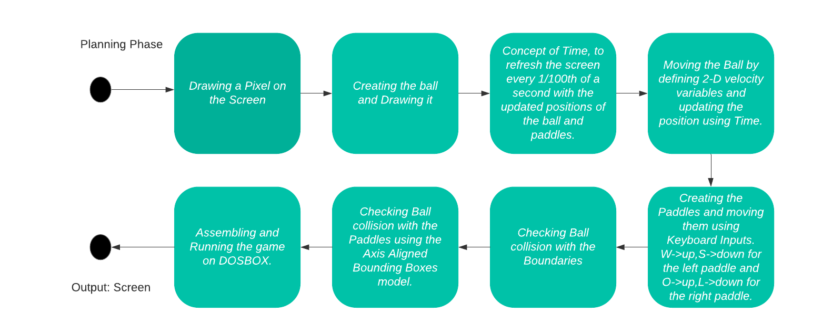

**CODE**

This code has been written by us entirely with reference from Wikipedia pages, documentation and domain specific resources about various interrupts and how to use them for each task as after that, the implementation is very straightforward.

The assembly directives used in our code:

* DUP: to initialize several locations at once (duplicate)
* DB/DW: *Define Byte* (declares 8-bit variable) and *Define Word* (declares 16-bit variable)
* SEGMENT: indicates the start of a logical segment.
* PROC: identifies the start of a procedure.
* PARA: used to align segment on paragraph boundary

The links for these resources have been given in the ‘References’ section at the end of this report. Below are the codes of the interrupt services and the formulae we referred to online:

For *INT 10H*

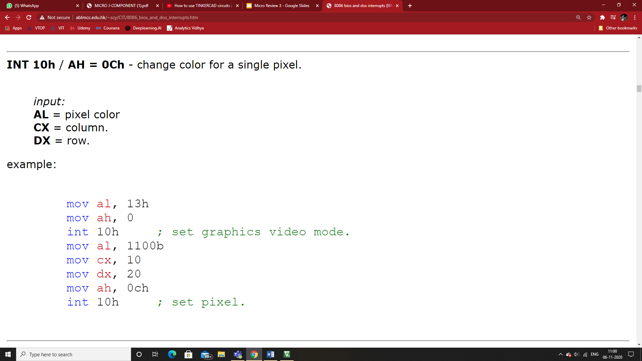

*For INT 16H*

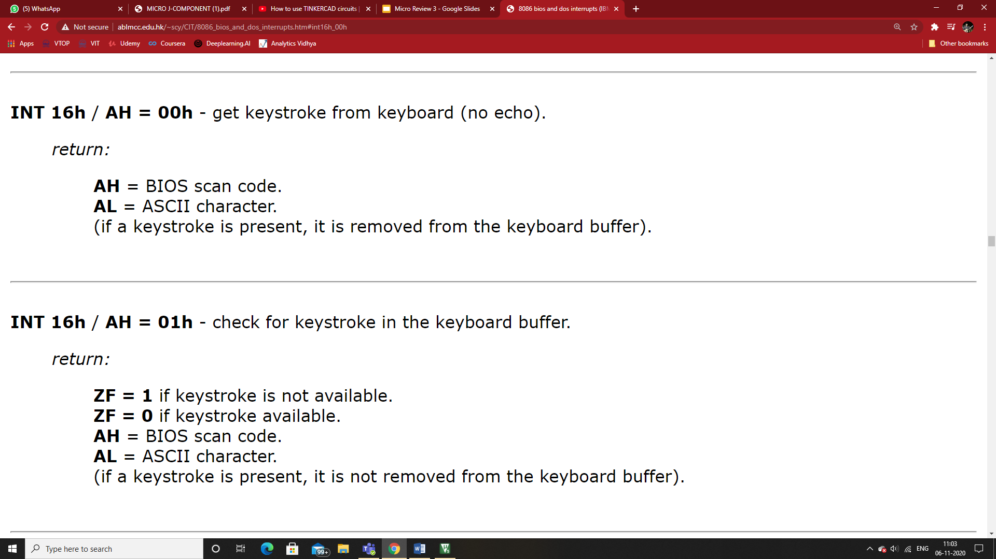

*For INT 21H*

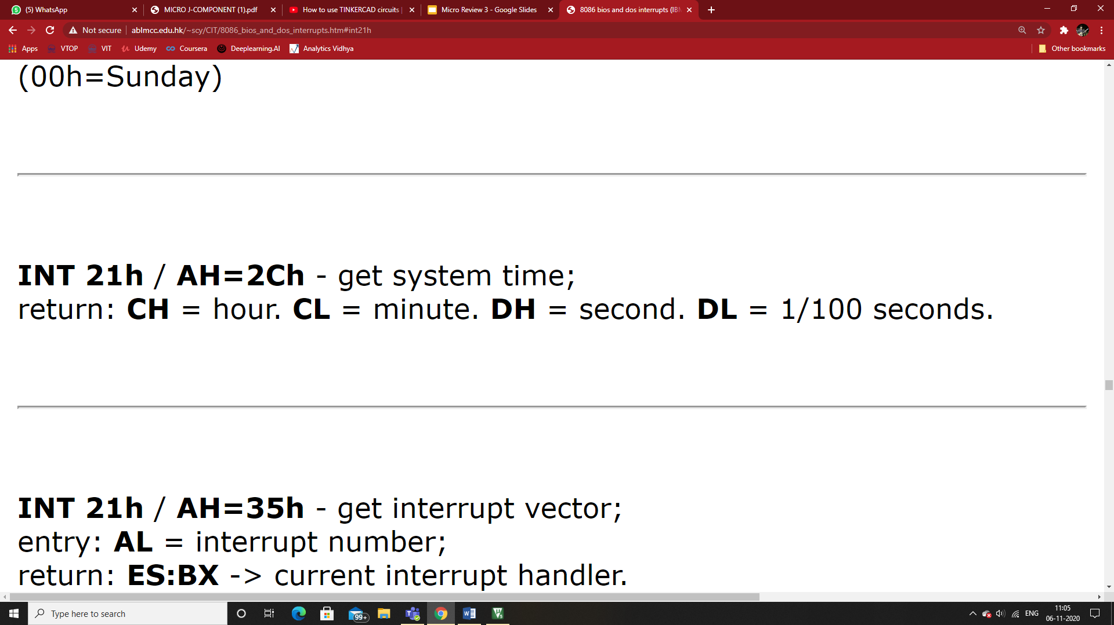

*Collision Detection Formula*

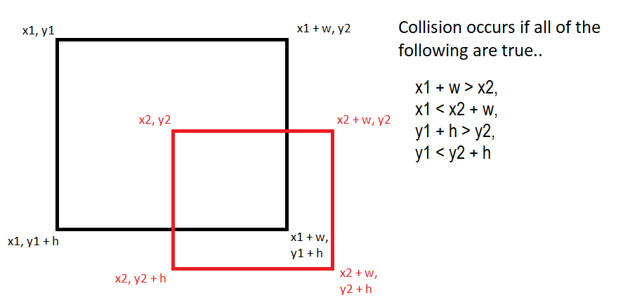

FINAL CODE

|  |
| --- |
| STACK SEGMENT PARA STACK                            ;start by creating a stack segment      DB 64 DUP (' ')                                 ;fill the stack with 64 empty spaces.  STACK ENDS  DATA SEGMENT PARA 'DATA'                            ;segment where we will save our variables      TIME_AUX DB 0      WINDOW_WIDTH DW 140h                            ;the width of the window (320 pixels)      WINDOW_HEIGHT DW 0C8h                           ;the height of the window (200 pixels)      WINDOW_BOUNDS DW 6                              ;variable used to check collisions early      BALL_ORIGINAL_X DW 0A0h                         ;x position of the ball at the beginning of the game.      BALL_ORIGINAL_Y DW 64h      BALL_X DW 0A0h                                  ;declaring the ball variables here (x and y posn's of the ball)      BALL_Y DW 64h       ;DWcan store 16 bits of info. We use it because we are using 16 bits registers.                                        ;DB can only store 8 bits of data.      BALL_SIZE DW 04h      ;size of the ball, 4 pixels on x(width) and on y(height). 16 pixels in total.      BALL_VELOCITY_X DW 05h      BALL_VELOCITY_Y DW 02h        PADDLE_LEFT_X DW 0Ah      PADDLE_LEFT_Y DW 0Ah        PADDLE_RIGHT_X DW 130h      PADDLE_RIGHT_Y DW 0Ah        PADDLE_WIDTH DW 05h      PADDLE_HEIGHT DW 1Fh      PADDLE_VELOCITY DW 05h  DATA ENDS  CODE SEGMENT PARA 'CODE'        MAIN PROC FAR                                   ;creating our main procedure(main function jaise)        ASSUME CS:CODE,DS:DATA,SS:STACK                 ;to clearly define the segments of our program.      ;code segment,data segment,stack segment.      ;assembler assumes that these are called code,data and stack.      ;useful for telling the assembler where to get the variables from(where they have been defined).      ;rather than using random garbage values.        PUSH DS                                         ;push to the stack the DS segment.      SUB AX,AX                                       ;clean the AX Register by subtracting it with itself      PUSH AX                                         ;push ax to the stack      MOV AX,DATA                                     ;save on the AX Register the contents of the DATA segment      MOV DS,AX                                       ;save on the data segment,the contents of AX.      POP AX                                          ;release the top item from the stack to the register      POP AX        CALL CLEAR_SCREEN        CHECK_TIME:          MOV AH,2Ch                                  ;set the configuration to get the system time. 2Ch is the function code on AH to get the system time.          INT 21h                                     ;we will use the interruption 21h. CH = hour CL = minute DH = second DL = 1/100 seconds          CMP DL,TIME_AUX                             ;check if the current time is equal to the previous one          JE CHECK_TIME                               ;JE stands for "Jump if condition is met". If DL and TIME_AUX are the same,check again. If not the same,then draw ball,move etc.            MOV TIME_AUX,DL                             ;Update the value of time_aux with the new value of dl. basically,update the time.            CALL CLEAR_SCREEN          CALL MOVE_BALL          CALL DRAW_BALL            CALL MOVE_PADDLES          CALL DRAW_PADDLES            JMP CHECK_TIME          RET        MAIN ENDP      MOVE_BALL PROC NEAR            MOV AX,BALL_VELOCITY_X          ADD BALL_X,AX                               ;move the ball horizontally            MOV AX,WINDOW_BOUNDS          CMP BALL_X,AX          JL RESET_POSITION                           ;BALL_X < 0 + WINDOW_BOUNDS (Y -> collided)            MOV AX,WINDOW_WIDTH          SUB AX,BALL_SIZE          SUB AX,WINDOW_BOUNDS          CMP BALL_X,AX                               ;BALL_X > WINDOW_WIDTH - BALL_SIZE  - WINDOW_BOUNDS (Y -> collided)          JG RESET_POSITION            MOV AX,BALL_VELOCITY_Y          ADD BALL_Y,AX                               ;move the ball vertically            MOV AX,WINDOW_BOUNDS          CMP BALL_Y,AX                               ;BALL_Y < 0 + WINDOW_BOUNDS (Y -> collided)          JL NEG_VELOCITY_Y            MOV AX,WINDOW_HEIGHT          SUB AX,BALL_SIZE          SUB AX,WINDOW_BOUNDS          CMP BALL_Y,AX          JG NEG_VELOCITY_Y                           ;BALL_Y > WINDOW_HEIGHT - BALL_SIZE - WINDOW_BOUNDS (Y -> collided)            ;here we check if the ball is colliding with the right paddle          ;maxx1>minx2 && minx1<maxx2 && maxy1>miny2 && miny1<maxy2. Condition for collision.          ;therefore BALL_X+BALL_SIZE>PADDLE_RIGHT_X && BALL_X<PADDLE_RIGHT_X+PADDLE_WIDTH && BALL_Y+BALL_SIZE>PADDLE_RIGHT_Y  && BALL_Y<PADDLE_RIGHT_Y+PADDLE_HEIGHT            MOV AX,BALL_X          ADD AX,BALL_SIZE          CMP AX,PADDLE_RIGHT_X          JNG CHECK_COLLISION_WITH_LEFT_PADDLE        ;jump if not greater,check if collision with left paddle          MOV AX,PADDLE_RIGHT_X          ADD AX,PADDLE_WIDTH          CMP BALL_X,AX          JNL CHECK_COLLISION_WITH_LEFT_PADDLE            MOV AX,BALL_Y          ADD AX,BALL_SIZE          CMP AX,PADDLE_RIGHT_Y          JNG CHECK_COLLISION_WITH_LEFT_PADDLE            MOV AX,PADDLE_RIGHT_Y          ADD AX,PADDLE_HEIGHT          CMP BALL_Y,AX          JNL CHECK_COLLISION_WITH_LEFT_PADDLE          ;if it reaches this point,means the ball collided with the right paddle.          NEG BALL_VELOCITY_X          RET            RESET_POSITION:              CALL RESET_BALL_POSITION              RET            NEG_VELOCITY_Y:              NEG BALL_VELOCITY_Y                     ;BALL_VELOCITY_Y = - BALL_VELOCITY_Y              RET          ;here we check if the ball is colliding with the left paddle          ;maxx1>minx2 && minx1<maxx2 && maxy1>miny2 && miny1<maxy2. Condition for collision.          ;therefore BALL_X+BALL_SIZE>PADDLE_LEFT_X && BALL_X<PADDLE_LEFT_X+PADDLE_WIDTH && BALL_Y+BALL_SIZE>PADDLE_LEFT_Y  && BALL_Y<PADDLE_LEFT_Y+PADDLE_HEIGHT          CHECK_COLLISION_WITH_LEFT_PADDLE:              MOV AX,BALL_X              ADD AX,BALL_SIZE              CMP AX,PADDLE_LEFT_X              JNG EXIT_BALL_MOVEMENT                  ;jump if not greater,check if collision with left paddle              MOV AX,PADDLE_LEFT_X              ADD AX,PADDLE_WIDTH              CMP BALL_X,AX              JNL EXIT_BALL_MOVEMENT                MOV AX,BALL_Y              ADD AX,BALL_SIZE              CMP AX,PADDLE_LEFT_Y              JNG EXIT_BALL_MOVEMENT                MOV AX,PADDLE_LEFT_Y              ADD AX,PADDLE_HEIGHT              CMP BALL_Y,AX              JNL EXIT_BALL_MOVEMENT              ;if it reaches this point,means the ball collided with the left paddle.              NEG BALL_VELOCITY_X              RET                EXIT_BALL_MOVEMENT:                  RET              RET        MOVE_BALL ENDP        MOVE_PADDLES PROC NEAR          MOV AH,01h                                   ;to check keystroke status          INT 16h          JZ CHECK_RIGHT_PADDLE_MOVEMENT               ;JUMP if ZERO FLAG(of Ah=01) is set. Meaning,if ZF=1,this means a key is being pressed.          ;left paddle movement          ;check if any key is being pressed(if not then exit procedure)          ;if being pressed,then check which key is being pressed(AL will store the ASCII character of the key being pressed)          MOV AH,00h                                   ;to read which key has been pressed          INT 16h          ;if it is 'w' or 'W', move up          CMP AL,77h                                   ;for 'w'. ASCII value of 'w' in hexadecimal          JE MOVE_LEFT_PADDLE_UP          CMP AL,57h                                   ;for 'W'.          JE MOVE_LEFT_PADDLE_UP            ;if it is 's' or 'S', move down          CMP AL,73h                                   ;for 's'. ASCII value of 's' in hexadecimal          JE MOVE_LEFT_PADDLE_DOWN          CMP AL,53h                                   ;for 'S'.          JE MOVE_LEFT_PADDLE_DOWN            JMP CHECK_RIGHT_PADDLE_MOVEMENT              ;if it reaches here,it means that they key pressed was neither w nor s            MOVE_LEFT_PADDLE_UP:              MOV AX,PADDLE_VELOCITY              SUB PADDLE_LEFT_Y,AX              MOV AX,WINDOW_BOUNDS              CMP PADDLE_LEFT_Y,AX              JL FIX_PADDLE_LEFT_TOP_POSITION          ;jumps if paddle left y is lesser than ax. 'y' position is 0 on top,AND IT INCREASES as we go down.              JMP CHECK_RIGHT_PADDLE_MOVEMENT            FIX_PADDLE_LEFT_TOP_POSITION:              MOV PADDLE_LEFT_Y,AX              JMP CHECK_RIGHT_PADDLE_MOVEMENT            MOVE_LEFT_PADDLE_DOWN:              MOV AX,PADDLE_VELOCITY              ADD PADDLE_LEFT_Y,AX              MOV AX,WINDOW_HEIGHT              SUB AX,WINDOW_BOUNDS              SUB AX,PADDLE_HEIGHT              CMP PADDLE_LEFT_Y,AX              JG FIX_PADDLE_LEFT_BOTTOM_POSITION       ;jumps if paddle left y is greater than ax              JMP CHECK_RIGHT_PADDLE_MOVEMENT            FIX_PADDLE_LEFT_BOTTOM_POSITION:              MOV PADDLE_LEFT_Y,AX              JMP CHECK_RIGHT_PADDLE_MOVEMENT          CHECK_RIGHT_PADDLE_MOVEMENT:              ;if it is 'o' or 'O', move up              CMP AL,6Fh                              ;for 'o'. ASCII value of 'o' in hexadecimal              JE MOVE_RIGHT_PADDLE_UP              CMP AL,4Fh                              ;for 'O'.              JE MOVE_RIGHT_PADDLE_UP                ;if it is 'l' or 'L', move down              CMP AL,6Ch                              ;for 'l'. ASCII value of 'l' in hexadecimal              JE MOVE_RIGHT_PADDLE_DOWN              CMP AL,4Ch                              ;for 'L'.              JE MOVE_RIGHT_PADDLE_DOWN              JMP EXIT_PADDLE_MOVEMENT            MOVE_RIGHT_PADDLE_UP:              MOV AX,PADDLE_VELOCITY              SUB PADDLE_RIGHT_Y,AX              MOV AX,WINDOW_BOUNDS              CMP PADDLE_RIGHT_Y,AX              JL FIX_PADDLE_RIGHT_TOP_POSITION        ;jumps if paddle left y is lesser than ax. 'y' position is 0 on top,AND IT INCREASES as we go down.              JMP EXIT_PADDLE_MOVEMENT            FIX_PADDLE_RIGHT_TOP_POSITION:              MOV PADDLE_RIGHT_Y,AX              JMP EXIT_PADDLE_MOVEMENT            MOVE_RIGHT_PADDLE_DOWN:              MOV AX,PADDLE_VELOCITY              ADD PADDLE_RIGHT_Y,AX              MOV AX,WINDOW_HEIGHT              SUB AX,WINDOW_BOUNDS              SUB AX,PADDLE_HEIGHT              CMP PADDLE_RIGHT_Y,AX              JG FIX_PADDLE_RIGHT_BOTTOM_POSITION     ;jumps if paddle left y is greater than ax              JMP EXIT_PADDLE_MOVEMENT            FIX_PADDLE_RIGHT_BOTTOM_POSITION:              MOV PADDLE_RIGHT_Y,AX              JMP EXIT_PADDLE_MOVEMENT          JMP EXIT_PADDLE_MOVEMENT          EXIT_PADDLE_MOVEMENT:              RET      MOVE_PADDLES ENDP        RESET_BALL_POSITION PROC NEAR          MOV AX,BALL_ORIGINAL_X          MOV BALL_X,AX            MOV AX,BALL_ORIGINAL_Y          MOV BALL_Y,AX          RET      RESET_BALL_POSITION ENDP        DRAW_BALL PROC NEAR                             ;to define a noew procedure that belongs to the same code segment. the main procedure can call this drawball procedure            MOV CX,BALL_X                               ;set the initial column (X position) of the pixel to 10          MOV DX,BALL_Y                               ;set initial y (row position) position to 10.          ;we draw one pixel in one line till we reach the width of 4.          ;do the same for each line till we reach 4 again.          ;we print 16 pixels(4*4).          ;this is done using the below loop          DRAW_BALL_HORIZONTAL:              MOV AH,0Ch                              ; set the configuration to writing a pixel              MOV AL,0Fh                              ; chooose white colour for the pixel              MOV BH,00h                              ; set the page number to zero              INT 10h                                 ;execute the configuration                INC CX                                  ;CX=CX+1 incrementing the column by 1.                                                      ;CX - BALL_X > BALL_SIZE (We check this condition. If this occurs,means we have reached the width of the ball,so we reset and go to the next line. If not,then we go to next column)              MOV AX,CX                               ;Using an auxiliary register AX so that we dont lose the current values.              SUB AX,BALL_X                           ;This difference increases with each iteration. This Diff is stored in AX.              CMP AX,BALL_SIZE                        ;comparing the two values              JNG DRAW_BALL_HORIZONTAL                ;JUMP,if NOT GREATER. if AX is not greater than ballsize,then loop this again.              ;this basically draws the columns.                ;if it reaches the below lines,means that AX became greater than ball_size.              ;now we have to go to the next line and do this again.              MOV CX,BALL_X                           ;resetting the column value to initial x position of the ball. CX register goes back to the initial column              INC DX                                  ;move to the next line              ;DX - BALL_Y > BALL_SIZE(to check if we have reached the final line).              ;if true,then we exit this procedure. otherwise,we move to next line.              MOV AX,DX              SUB AX,BALL_Y              CMP AX,BALL_SIZE              JNG DRAW_BALL_HORIZONTAL            RET                                         ;to exit this procedure      DRAW_BALL ENDP                                  ;denotes the end of this procedure        DRAW_PADDLES PROC NEAR          MOV CX,PADDLE_LEFT_X          MOV DX,PADDLE_LEFT_Y            DRAW_PADDLE_LEFT_HORIZONTAL:              MOV AH,0Ch                              ;set the configuration to writing a pixel              MOV AL,0Fh                              ;chooose white colour for the pixel              MOV BH,00h                              ;set the page number to zero              INT 10h                                 ;execute the configuration                INC CX              MOV AX,CX              SUB AX,PADDLE_LEFT_X              CMP AX,PADDLE_WIDTH              JNG DRAW_PADDLE_LEFT_HORIZONTAL              MOV CX,PADDLE_LEFT_X              INC DX              MOV AX,DX              SUB AX,PADDLE_LEFT_Y              CMP AX,PADDLE_HEIGHT              JNG DRAW_PADDLE_LEFT_HORIZONTAL            MOV CX,PADDLE_RIGHT_X                       ;set the initial column (X)          MOV DX,PADDLE_RIGHT_Y                       ;set the initial line (Y)            DRAW_PADDLE_RIGHT_HORIZONTAL:              MOV AH,0Ch                              ;set the configuration to writing a pixel              MOV AL,0Fh                              ;choose white as color              MOV BH,00h                              ;set the page number              INT 10h                                 ;execute the configuration                INC CX                                  ;CX = CX + 1              MOV AX,CX                               ;CX - PADDLE_RIGHT_X > PADDLE_WIDTH (Y -> We go to the next line,N -> We continue to the next column              SUB AX,PADDLE_RIGHT_X              CMP AX,PADDLE_WIDTH              JNG DRAW_PADDLE_RIGHT_HORIZONTAL                MOV CX,PADDLE_RIGHT_X                   ;the CX register goes back to the initial column              INC DX                                  ;we advance one line                MOV AX,DX                               ;DX - PADDLE_RIGHT_Y > PADDLE_HEIGHT (Y -> we exit this procedure,N -> we continue to the next line              SUB AX,PADDLE_RIGHT_Y              CMP AX,PADDLE_HEIGHT              JNG DRAW_PADDLE_RIGHT_HORIZONTAL          RET      DRAW_PADDLES ENDP        CLEAR_SCREEN PROC NEAR                          ;clear the screen by resetting the video mode              MOV AH,00h                              ;set the configuration to video mode              MOV AL,13h                              ;choose the video mode. set it to 13h(is a part of provides 256 color graphics)              INT 10h                                 ; execute the configuration                MOV AH,0Bh                              ;set the configuration              MOV BH,00h                              ;to the background color              MOV BL,00h                              ;choose black as background. 00h is the colour code for black              INT 10h                                 ;execute the configuration              RET      CLEAR_SCREEN ENDP    CODE ENDS  END |

**STEP-BY-STEP REPORT**

* Creating a blank screen

CLEAR_SCREEN PROC NEAR

    MOV AH,00h

    MOV AL,13h

    INT 10h

    MOV AH,0Bh

    MOV BH,00h

    MOV BL,00h

    INT 10h

    RET

CLEAR_SCREEN ENDP

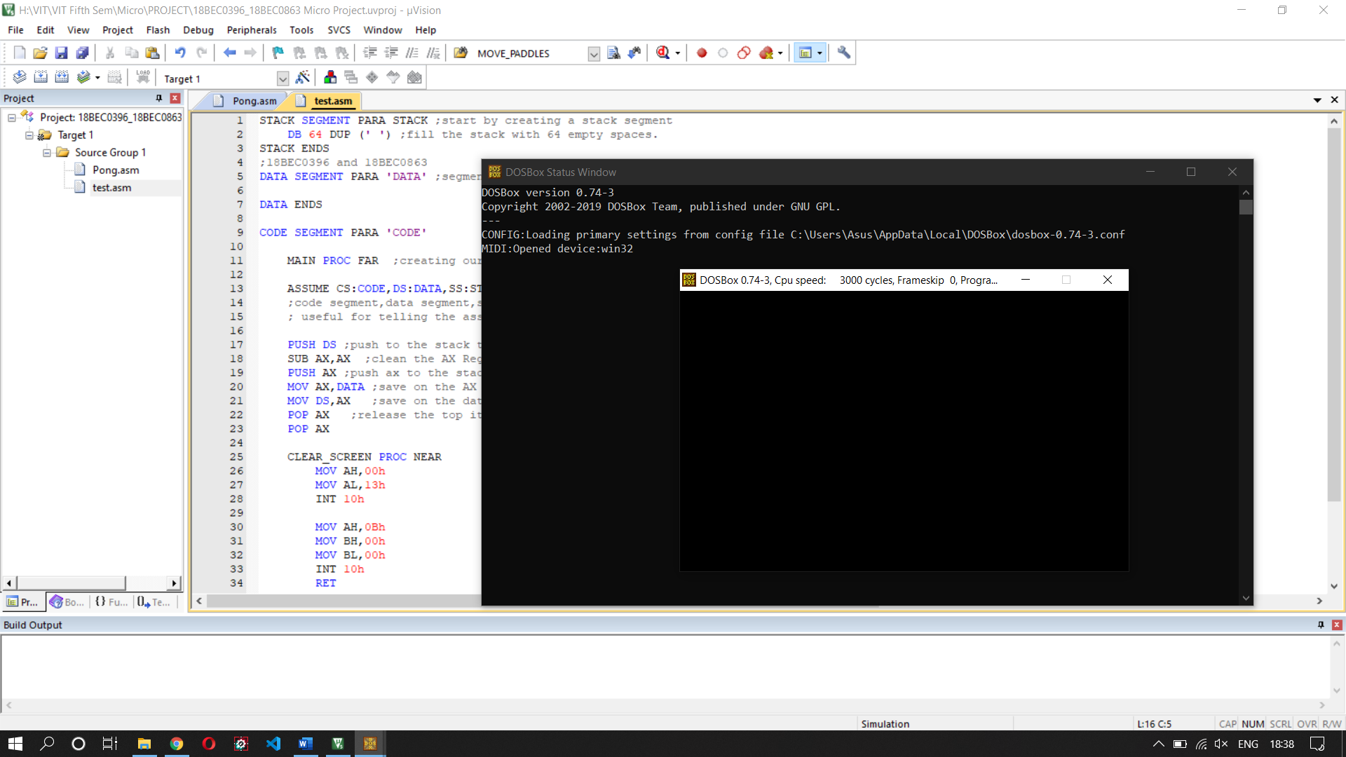

* Drawing the ball

MOV CX,BALL_X

MOV DX,BALL_Y

DRAW_BALL_HORIZONTAL:

    MOV AH,0Ch

    MOV AL,0Fh

    MOV BH,00h

    INT 10h

    INC CX

    MOV AX,CX

    SUB AX,BALL_X

    CMP AX,BALL_SIZE

    JNG DRAW_BALL_HORIZONTAL

    MOV CX,BALL_X

    INC DX

    MOV AX,DX

    SUB AX,BALL_Y

    CMP AX,BALL_SIZE

    JNG DRAW_BALL_HORIZONTAL

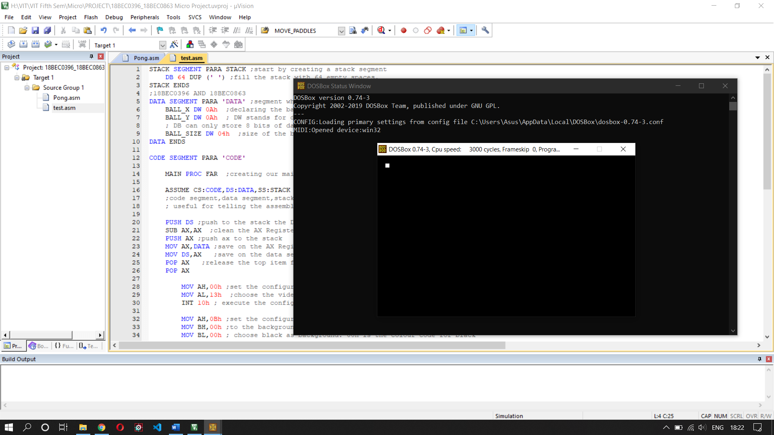

* Time Monitoring

CHECK_TIME:

    MOV AH,2Ch

    INT 21h

    CMP DL,TIME_AUX

    JE CHECK_TIME

    MOV TIME_AUX,DL

    CALL CLEAR_SCREEN

    CALL MOVE_BALL

    CALL DRAW_BALL

    JMP CHECK_TIME

* Moving the ball

MOVE_BALL PROC NEAR

    MOV AX,BALL_VELOCITY_X

    ADD BALL_X,AX

    MOV AX,BALL_VELOCITY_Y

    ADD BALL_Y,AX

MOVE_BALL ENDP

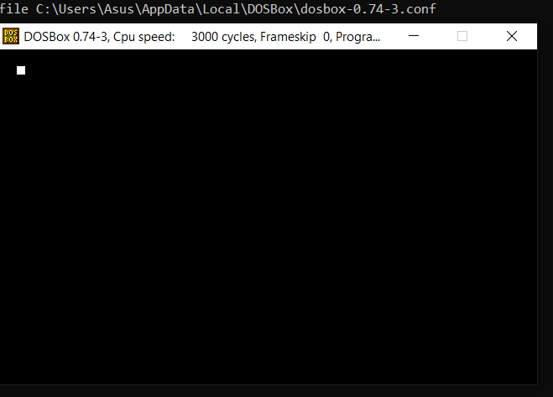

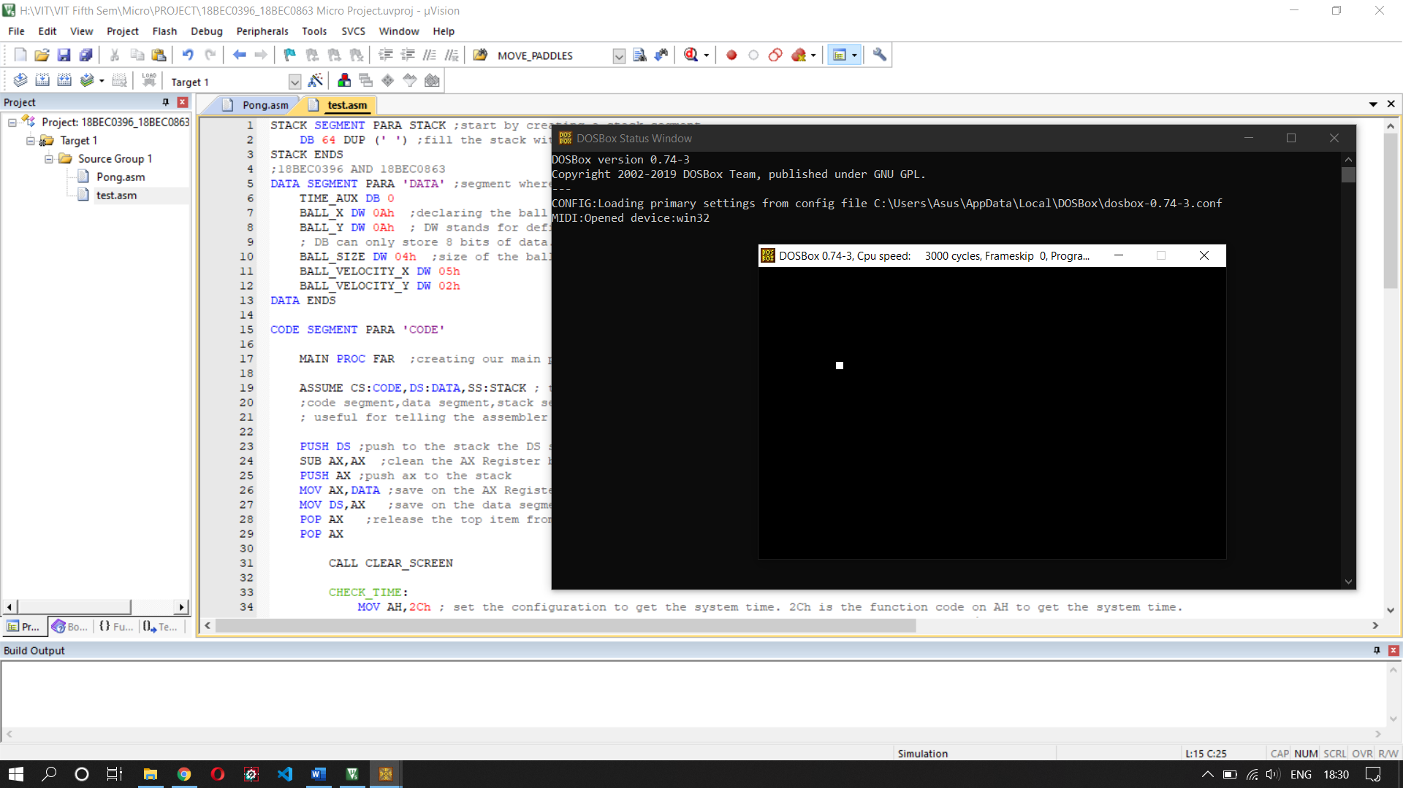

* Creating Paddles

MOV AX,BALL_X

ADD AX,BALL_SIZE

CMP AX,PADDLE_LEFT_X

JNG EXIT_BALL_MOVEMENT

MOV AX,PADDLE_LEFT_X

ADD AX,PADDLE_WIDTH

CMP BALL_X,AX

JNL EXIT_BALL_MOVEMENT

MOV AX,BALL_Y

ADD AX,BALL_SIZE

CMP AX,PADDLE_LEFT_Y

JNG EXIT_BALL_MOVEMENT

MOV AX,PADDLE_LEFT_Y

ADD AX,PADDLE_HEIGHT

CMP BALL_Y,AX

JNL EXIT_BALL_MOVEMENT

NEG BALL_VELOCITY_X

RET

EXIT_BALL_MOVEMENT:

    RET

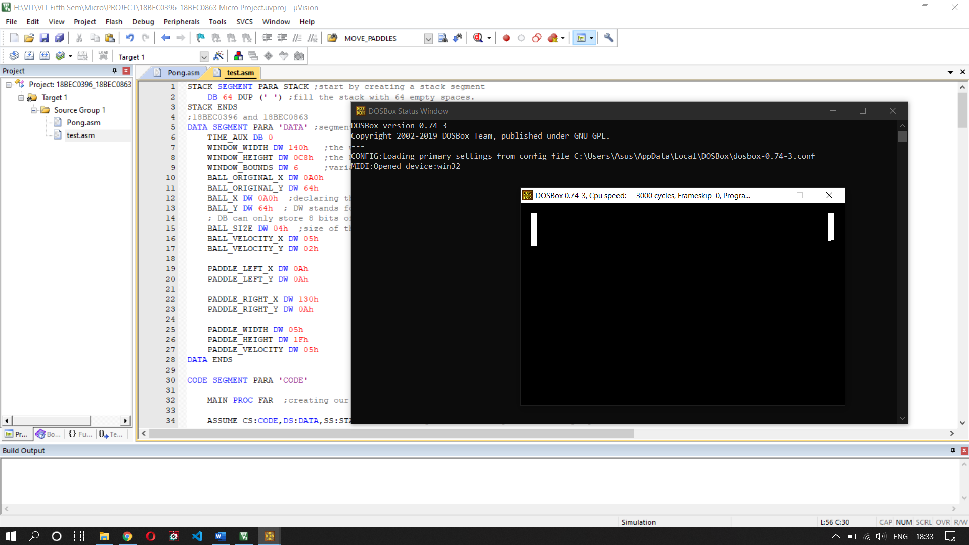

* Collision

MOV AX,BALL_X

ADD AX,BALL_SIZE

CMP AX,PADDLE_LEFT_X

JNG EXIT_BALL_MOVEMENT

MOV AX,PADDLE_LEFT_X

ADD AX,PADDLE_WIDTH

CMP BALL_X,AX

JNL EXIT_BALL_MOVEMENT

MOV AX,BALL_Y

ADD AX,BALL_SIZE

CMP AX,PADDLE_LEFT_Y

JNG EXIT_BALL_MOVEMENT

MOV AX,PADDLE_LEFT_Y

ADD AX,PADDLE_HEIGHT

CMP BALL_Y,AX

JNL EXIT_BALL_MOVEMENT

NEG BALL_VELOCITY_X

RET

EXIT_BALL_MOVEMENT:

    RET

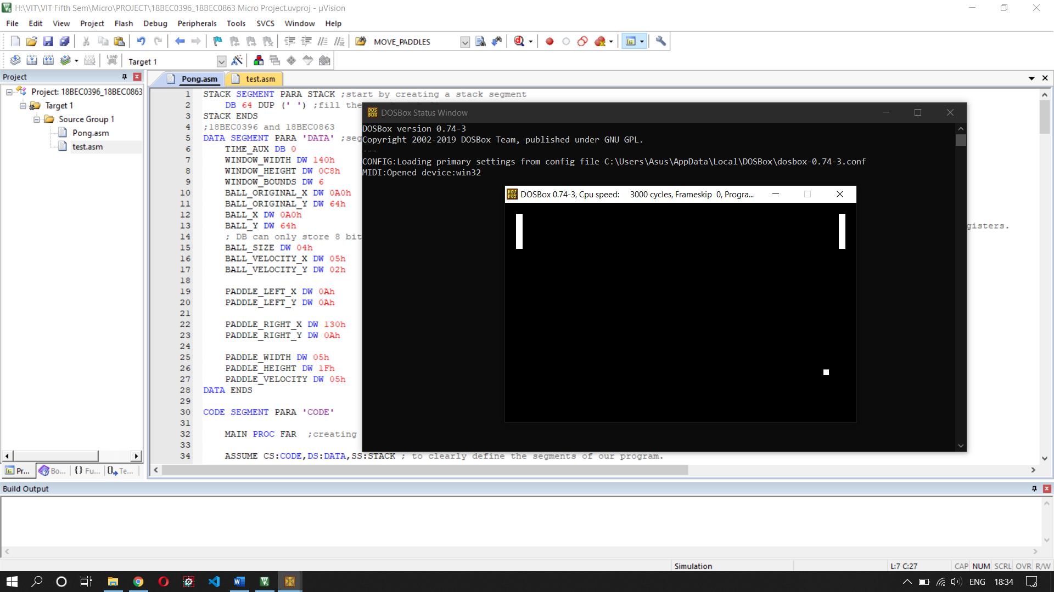

If ball collides with any of the paddles or the top/bottom edges of the frame, the game continues.

**RUNNING THE GAME (DOSBOX COMMANDS)**

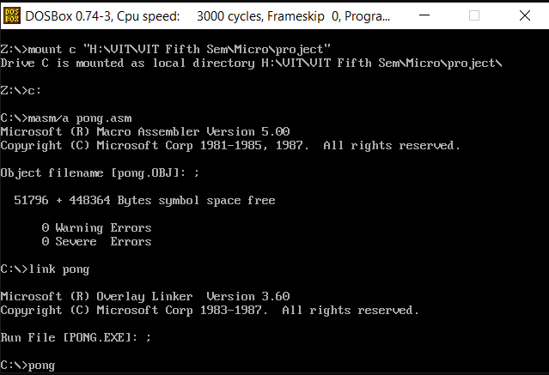

What you see here is the DOSBOX terminal, which is basically used for emulating an 80806 processor so that legacy programs can be executed on it. This is a snapshot of the commands used to play the game. The commands are:

1. *masm /a pong.asm*

MASM stands for Microsoft Macro Assembler. It is an x86 assembler, and we use it for converting our assembly code file (pong.asm) into machine language. This process creates an obj file.

1. *link pong*

This command is used to link the pong.obj file (object file) by using the linker. The process of linking resolves all the references to other .obj files and is therefore responsible for linking all the keywords/pre-defined functions we use in our code with their true meaning. The process of linking generates an executable (.exe) file.

1. *pong*

This command is just to run the application’s executable file that was generated by the linker. Running this command starts the game.

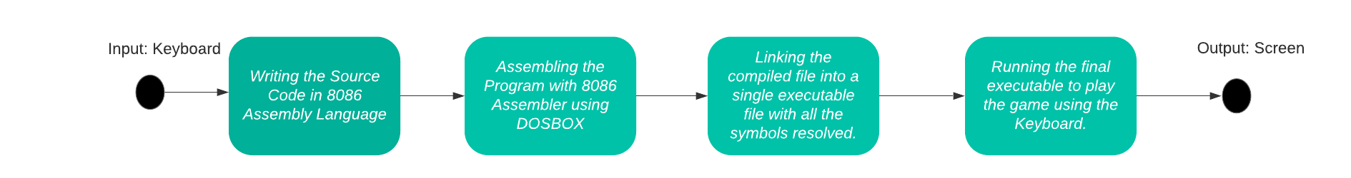

Fig: Flowchart of the above process

**RESULTS**

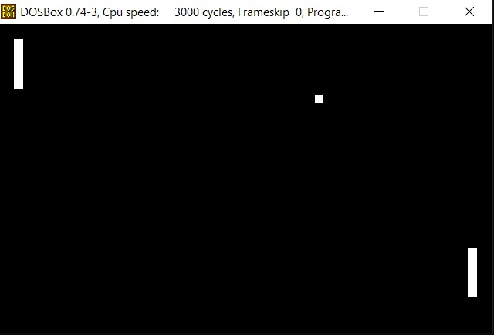

Fig: Final game running smoothly in our x86 emulator DOSBOX.

**CONCLUSION**

We have successfully recreated the Pong game using only Assembly Language, and in the process, have gained useful knowledge about 8086 architecture and its programming.

**REFERENCES**

1. <https://en.wikipedia.org/wiki/INT_10H>
2. <https://stanislavs.org/helppc/int_10-0.html>
3. <https://www.stanislavs.org/helppc/int_16.html>
4. <http://spike.scu.edu.au/~barry/interrupts.html>
5. <https://www.azurefromthetrenches.com/introductory-guide-to-aabb-tree-collision-detection/>
6. <https://www.tutorialspoint.com/microprocessor/microprocessor_8086_overview.htm>
7. <http://ftp.it.murdoch.edu.au/units/ICT106/Practicals/ict106_pract_week9.pdf>
8. <https://www.elprocus.com/8086-assembly-language-programs-explanation/>